A holistic approach for quality assurance and advanced decision making for academic institutions using the balanced scorecard technique

Ioannis Chalaris
Depart. of Informatics, TEI of Athens
Ag. Spyridonos 28, Aigaleo, 12210, Greece
tel +306937853873
ixalaris@teiath.gr
Manolis Chalaris
Depart. of Informatics,TEI of Athens
Ag. Spyridonos 28, Aigaleo, 12210, Greece
tel +306937853873
manoshlr@teiath.gr
Stefanos Gritzalis
Depart. of Information & Communication Systems Engineering, University of Aegean,
Karlovassi, Samos, 83200, Greece
sgritz@aegean.gr

ABSTRACT
Quality assurance in higher education has been established officially, through the establishment of appropriate procedures and through the appointment of supervising bodies. After an initial period of experimental application of evaluation activities, the need for optimization of processes and exploitation of recorded observation has arisen; the obvious aim is the provision of educational processes in accordance with the quality standards. Within the aforementioned framework the Balanced Scorecard technique provides a useful framework that assists in converting the organizational scope to measurable indexes and processes. This procedure however, in order to be applied to the educational domain, demands an appropriate adjustment of the model to the educational needs. Within this framework, this work describes an attempt to develop the required infrastructure in processes, information systems and regulations for a technological institution, in order to ensure quality in relation to the goals agreed by the Hellenic Quality Assurance and Accreditation Agency and support the administration of a higher education institution in taking decisions in a contemporary and continuously improved manner.
Categories and Subject Descriptors
J.1 [Computer Applications]: Administrative data processing - Education
General Terms
Management, Measurement, Documentation, Performance.
Keywords
Quality Assurance in Higher Education; Balanced Scorecard Technique; Strategy map; Information System; Decision Making

INTRODUCTION

Permission to make digital or hard copies of all or part of this work for personal or classroom use is granted without fee provided that copies are not made or distributed for profit or commercial advantage and that copies bear this notice and the full citation on the first page. Copyrights for components of this work owned by others than ACM must be honored. Abstracting with credit is permitted. To copy otherwise, or republish, to post on servers or to redistribute to lists, requires prior specific permission and/or a fee. Request permissions from Permissions@acm.org.
PCI '14, October 02 - 04 2014, Athens, Greece
Copyright 2014 ACM 978-1-4503-2897-5/14/10…$15.00.
http://dx.doi.org/10.1145/2645791.2645820
Quality assurance pays emphasis to the external perception of an enterprise as well as to the management of productivity, human resources management and to the integration of the structural domains in one; in order to effectively monitor these parameters, appropriate indexes are necessary [7], [9]. Large corporations use indexes of financial nature in accordance with other indexes which are selected in order to reflect the scope, the vision and the future strategy.
The balanced scorecard approach addresses this need in a systematic way by translating the organization’s mission and strategy into a set of performance measures and providing a framework for strategic management and measurement [8]. The balanced scorecard looks at an organization from four perspectives (known as four perspectives of BSC):
• Financial: How do we look to shareholders (stakeholders in public sector and Higher education)?
• Internal business processes: What must we excel at?
• Innovation and Learning: How can we continue to improve and create value?
• Customer: How do our customers see us?
In order to apply the aforementioned model to non for profit organizations and academic institutions several amendments to the model need to be made. For example the financial aspect serves as a second priority since there is no direct money flow from customers to the organization. The rest of the paper is structured as follows: after the brief introduction, section 2 presents related work; section 3 presents the modified BSC technique for an academic institution; section 4 presents the holistic quality assurance approach, the architecture of the supporting information system and a pilot case study; section 5 concludes the paper.

RELATED WORK
Wu et al [12] propose a method to evaluate extension education centers in universities. In their research they use the BSC as for the extraction of basic evaluation indexes. The data set is based on field study and accordingly with the use of statistical techniques they use relative weights and create matrixes which at the end help with the extraction of useful conclusions.
Many different other methodologies have been proposed for the evaluation. Among else the data envelopment analysis has been applied in the case of IT based evaluation. However this technique suffers from the ability to predict the future directions in an organization’s plan by estimating existing data [1].
Schniederjans and Wilson [10] used a combination of analysis hierarchical process (AHP) and goal programming. They found that the combination of these techniques shows better results from each one separately.
In [13] the authors proposed a model for evaluating an organization’s efficiency using DEA. Their model except from financial measures considers also information and system quality. They also showed that DEA cannot model the efficiency related parameters of the organization under evaluation and to identify their potential efficiency problems.
In [5] a prototype of a quality assurance information system is being proposed which will interact with the BSC tool and thus will support the administration of the institute in taking decision for the improvement of the quality of the educational and operational processes and in setting its strategic objectives.
Chalaris et al [3] make a first attempt to use the Balanced Scorecard as a tool for an Informatics Department. They attempt to transform the model to suit the needs for an academic department. They attempt to record the department mission of knowledge creation, sharing and utilization into a comprehensive, coherent, communicable and mobilizing framework—for stakeholders and to develop a framework for future use.

STRATEGIC PLANNING IN HEI USING BSC
The main scope of the BSC was the replacement of a traditional evaluation system which considered only the financial parameters. The BSC signals a new approach which considers not only the financial perspective, but different perspectives such as the client’s perspective, production monitoring and employee’s advancement.
In addition, evaluation methods which will be equally balanced should be taken into consideration in order to encourage organizations to increase productivity.
The four distinct perspectives are:
• Financial perspective: This reflects the previous organization operation of an organization, the degree of achievement of economic targets included. It also refers to the level to which the enterprise develop, profit or are exposed to risks according to the organizational strategies.
• The client’s perspective: It refers to the degree to which operations exploit unique features in order to differentiate from competitors or in order to gain more customers. Important indexes in this category are the profit per person, the satisfaction of clients and the market share.
• Internal perspective: It refers to the degree in which the internal processes follow some operating plan and how much they try to achieve maximum performance.
• Learning and development prospects: This perspective refers to the degree to which organizations attempt to achieve sustainable operation through learning and development. This perspective according to Norton is directly linked to the degree of inclusion of Information Systems in the organization’s lifecycle and also to the strengthening of the average employee capabilities.
The finale purpose of BSC is to support managers by providing them all the factors for aligning the performance of the organisation with its strategy.
The adaptation and application of BSC in the education context has not been researched and described extensively. When a higher education institute wants to apply BSC it should emphasize in academic measures than in financial performance [4].
The following table presents some indicators and their description that have been modified in order to match for the application of BSC in higher education area.

Table 1. Modified BSC indicators for higher
Financial
Total income | Aggregated income
Cost control | Measures to reduce costs
Budget monitoring | Incoming/outgoing flow monitoring
Productivity | Ratio of income/expenses
Customer
Student satisfaction | Evaluation of provided services
Feedback from students | Communication with the students
Registering new students | Increase in the number of students
Market share | The share of the institution in respect to other institutions in total
Quality | If there exists some quality management system
Internal processes
Adjustment of curricula | If the curriculum is updated regularly
Evaluation of services | Existence of internal and external evaluation processes
Standardized services | Adoption of standards for service provision
Learning and growth
Employees satisfaction | Degree of satisfaction of academic and administrative personnel
Facilities | Available facilities and means
Stable working environment | If the working environment provides stable conditions for personnel

The BSC model as aforementioned attempts to capture the semantics between the different aspects of an organization without considering only the financial parameter as other models: it also tackles with issues that affect directly or indirectly the organization’s strategy.
Thus, it achieves the alignment of the assessment systems of an institution with its strategy in all levels and gives the administration the opportunity to get a comprehensive insight into the operation of the institute by monitoring the KPIs set for evaluating the strategic objectives. This can be considered as an important success factor for achieving long-term sustainability within the requirements arising from the new model of organization and functioning of the institutions and the requirement of quality standards proposed by the Hellenic Quality Assurance and Accreditation Agency (ADIP).
Furthermore, through the application of the BCS model in a HEI, a culture of continuous assessments and performance management for all stakeholders will be established. But also very important is that all stakeholders will realize how each one’s work will affect the total good of the institute, and the importance of monitoring the progress of their attempts.
What we suggest is that the development and management of the strategic map for a higher educational institute should follow the here-below reasoning, visualized in the following figure.

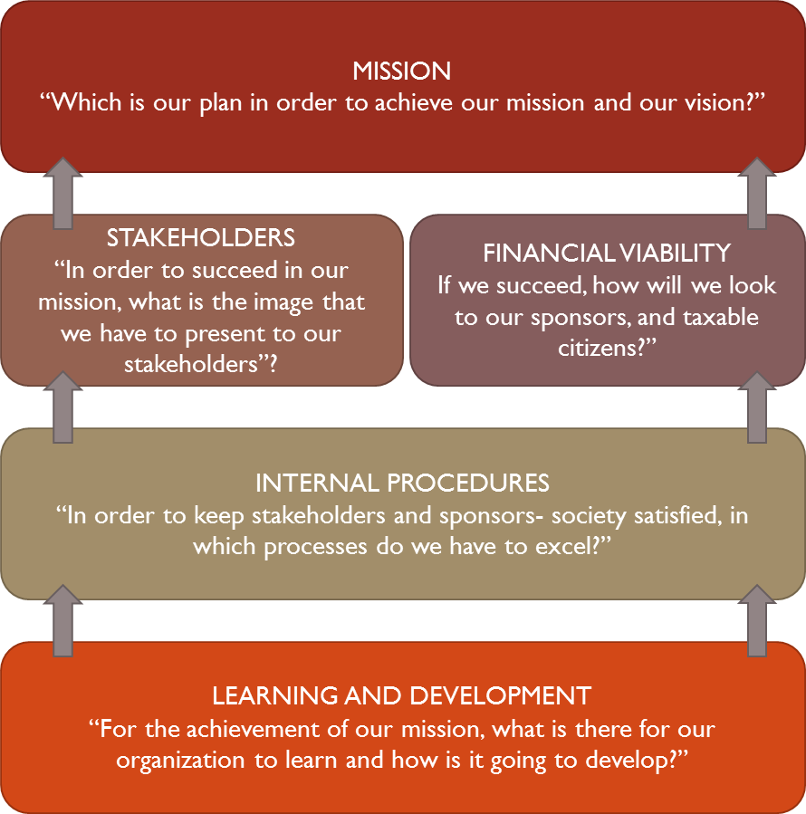
- The basic structure of the Strategic map of a Higher Educational Institute
Based on this reasoning and taking into consideration the assessment model proposed by ADIP, we tried to implement a strategy map (see Fig. 2) for the department of Informatics of TEI-A as a first pilot attempt.
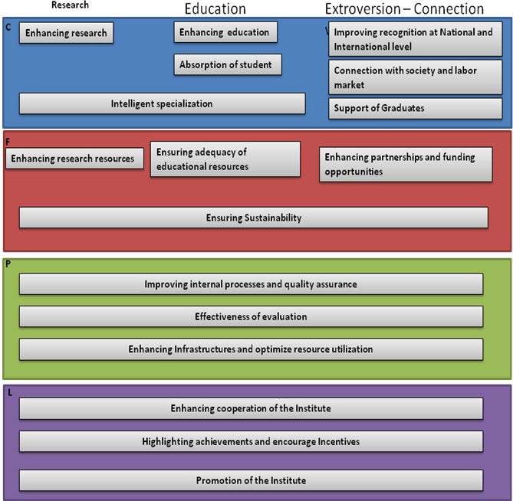
- Strategy map of the department of Informatics of TEI-A
Our objective is to activate a dialogue within the departments of a HEI, by means of visualized results of the evaluation aspects, on what the current situation is and what can be done, in order to define an academic strategy and achieve the strategic objectives. In our pilot attempt, we started by proposing a strategy map for the department of Informatics of TEI-A and we try to find out for all aspects of ADIP’s assessment and in every question, possible values, the source of taking the answer and the measurement process that needs to be set. Moreover, for every dimension we assigned a weighting factor. The weighing factors have been set somewhat arbitrarily, in order to start a discussion on these dimensions within the Department.

QUALITY ASSURANCE AND ALLIANCE WITH STRATEGY FOR HIGHER EDUCATIONAL INSTITUTIONS
The basic mission of our approach is to try to integrate the Quality assurance process into the strategic framework. The design and establishment of a Quality Assurance System is of particular value. Such a system should implement basic principles (sometimes defined by the supervisory framework) and also to be able to interpret large sets of data. In more detail the Quality System (QS) needs to include:
- Processes for the support of the organization of evaluation with possibilities of safe import of standardized data
- Pumping data from the existing individual information systems of the institute
- Reliable result management
- Publishing of reports in internet environment and
5. Decision making mechanisms
The objective of the quality assurance information system is to lead to the processes of decision-making, strategic planning based on the environment of the institution and efficient management of available resources in order to meet the quality requirements of the services provided to all stakeholders (students, teachers, staff, state, etc.). We have implemented a pilot information system at a Greek Educational Institution, the Technological Education Institution of Athens (TEI-A).

Architecture of the Information System of the Quality Assurance Unit ΤΕΙ-Α
The Information System that supports the Quality Assurance Unit consists of three modules:
- Academic Unit Assessment Data, which collects all the necessary data for the preparation of internal evaluation, reports of the departments of TEI of Athens (census records of scientific staff members, course evaluation questionnaires from students, etc.).
- Subsystem Logging Evaluation Data from Administration Units, which will collect all the necessary data for the evaluation of central administrative units of the institute.
- Database Subsystem and Assessment Report Repository, which will support the monitoring, intersection and exchange of any kind of data and indexes recorded.
In order to achieve interoperability of the quality assurance information system with other existing information systems of TEI of Athens, the appropriate interfaces were developed to allow for data exchanging and maximizing data reuse.
Additionally, another module is able to link the reports produced by the Information System with the methodology tools that support the modified BSC technique as referred to previous section; this module makes usage of the ADOscore modelling tool.
Figure 2 depicts our approach. The strategy and vision of the institution are considered in the planning process which defines roles and services. The two lower layers define the practical implementation phases of our approach.
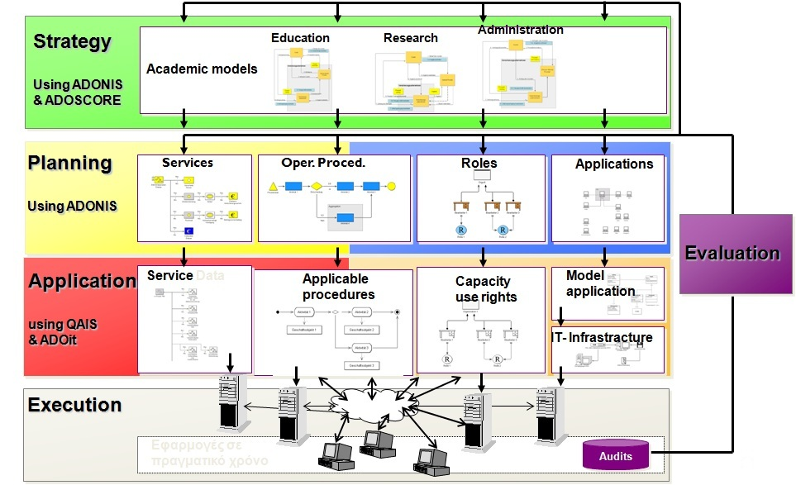
- System Architecture and interfaces
Fig. 3 depicts the architecture of the Quality Assurance Information System (QAIS) which is presented in [5] and the interaction with subsystems that support the decision making in academic strategic management. The QAIS system is linked directly with different repositories that store quality related data. These data are processed by subsystems like ADOSCORE and Information System for Research Management (I.RE.MA) [11] that enables extraction of useful conclusions that support the decision making procedure.
Our system consists of the following layers:
- The process modeling layer; this layer is aligned with the Quality Assurance and Accreditation Agency and is also ISO certified.
- The Information Processing layer, which is responsible for data collection and processing in respect to the evaluation sectors. We must note that when the administrator approves the quality model (the modeled processes) then the system is fed with the respective quality indexes which are extracted from the agreed processes every two years.
- The Research Management layer (IREMA) which uses advanced visualization techniques directly linked to quality indexes which monitor the research progress.
- The strategic management layer which involves the follow up processes with the updated indexes related to the educational, research and administrative work at the institution

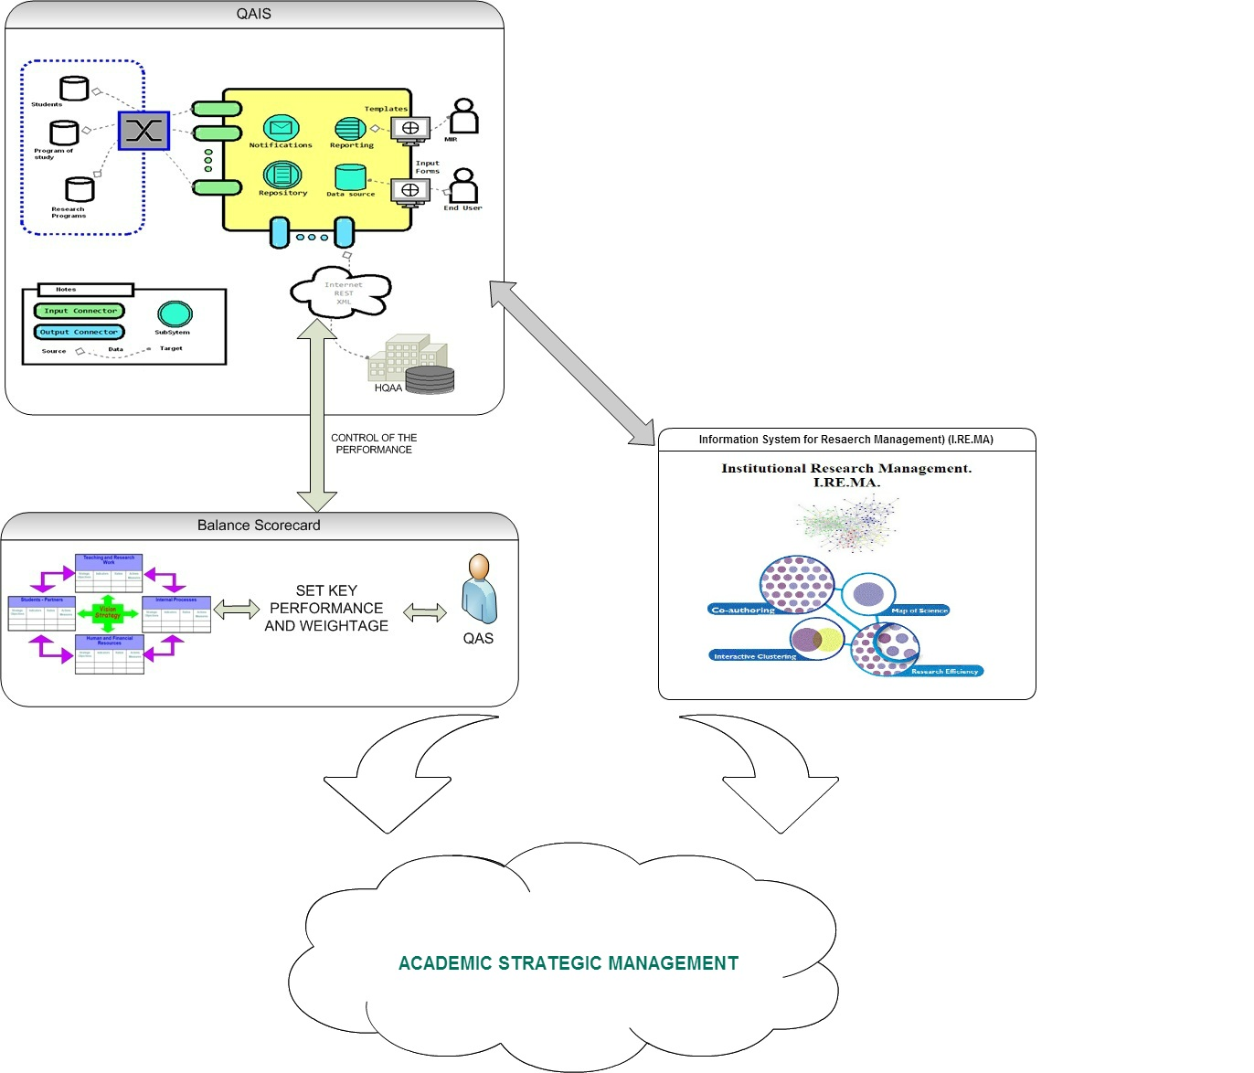
- QAIS architecture and interaction with subsytems
Upon completion of all the evaluation levels and according to the architecture depicted in Figures 1 and 2 the Information System is desirable to inform the administrator upon potential problems and also to provide to them the general functioning picture in order to support follow up processes. Our final targeting is through the evaluation results extracted in the end of a two year term the Vice Rector who is responsible for quality assurance to make the necessary amendments in order to improve processes or to adjust the focus on the new facts that the state proposes for the functioning of the department. Through this process the requirements set by the state-ruled quality assurance agency are adequately covered.

Pilot implementation: Monitoring Quality at ΤΕΙ-Α
The attempt to implement a holistic approach that identifies Quality assurance using methodologies such as the BSC is a complex task; a lot of factors need to be aligned in order to ensure the success of the task (upper-management support, funding, commitment from academic personnel etc). As a pilot study, the Quality Assurance Unit at TEI-A supports the task of providing feedback using different types of data and also by using tools that allow mapping processes and roles to a BSC compatible approach. So far the Quality assurance unit has completed the following tasks as part of our methodology:
- Explicit Quality policies have been communicated to the Departments
- All the relevant reports from the Departments need to be submitted officially and updated on a yearly basis
- Roles and responsibilities for each process step have been explicitly defined.
- Annual management review in order suggestions to be evaluated and integrated to the current policies.
- Ability and necessity for written failures report (complaints, malfunctions) so as to have timely and effective measures on improvement and prevention
- Existence of quality objectives, that are set and revised at least annually
These processes which have been established officially and which are integrated in the Institutions’ regulatory framework allow the determination of strategic decisions upon the Institution’s future.

CONCLUSIONS – FUTURE WORK
Ensuring quality in a modern institution is a challenging task. It demands complex processes, and exploitation of various data. Existing methodologies that link quality metrics to strategic decisions cannot be implemented in the academic domain without amendments; therefore a holistic approach that maps existing methodologies to the academic environment is required. Such an approach is still under development and initial results have been presented as a pilot study in a Greek Higher Education institution. In this work we have presented the challenges faced when mapping the traditional BSC technique to the academic domain; we attempted to propose a strategy map for a specific department and define measurable indexes in order to align a quality monitoring framework with the BSC methodology. This process is assisted by an Information System designed for this purpose which manipulates data from different types of repositories in order to provide the Quality Assurance Units with the appropriate reports, helping the upper level management to direct the future strategic decisions.
As future work, we have to complete the definition of the performance indicators and the way and frequency of collecting the needed data; we have to measure the current situation of the performance indicators and set the thresholds for each target; we have to transfer the performance model to a Strategy & Performance Management tool, like ADOscore of the company BOC Austria and after the accomplishment of all that, we can roll out at an institutional level.

ACKNOWLEDGMENTS
The Quality Assurance Information System of TEI of Athens, which is the developing phase, is funded by the project “MODIP of TEI of Athens” – NRSF 2007-2013. This work has been partially co-funded by the European Union (Social Fund) and Greek national resources under the framework of the "Archimedes III: Funding of Research Groups in TEI of Athens" project of the Education and Lifelong Learning operational Programme.

REFERENCES
- Asosheh, A., Nalchigar, S. & Jamporazmey, M. (2010). Information technology project evaluation: An integrated data development analysis and balanced scorecard approach. Expert Systems with Applications, 37, 5931-5938.
- Bayer, F.; Kühn, H.; Junginger, S.; Petzmann, A.: E-BPMS: Ein Modellierungs-Framework für E-Business-Anwendungen. In: Bauknecht, K.; Brauer, W.; Mück, Th. (Eds.): Proceedings of the Informatik 2001 - Wirtschaft und Wissenschaft in der Network Economy: Visionen und Wirklichkeit. University of Vienna, Austria (2001) 922-927
- Chalaris I, Poustourli C, Quality Continuous Improvement in Higher Education with Balance Scorecard Technique proceedings of Management of International Business and Economics Systems 2013, Larissa, Greece
- Umashankar, V., Dutta, K. (2007). Balanced scorecards in managing higher education institutions: an Indian perspective, International Journal of Educational Management, 21(1), 54-67.
- Chalaris M., Tsolakidis An., Sgouropoulou C., Chalaris I. Developing an Information System for Quality Assurance in Higher Education using the Balanced Scorecard Technique - The case study of TEI-A, PCI 2011 in press. ISBN 978-0-7695-4389-5.DOI 10.1109/ PCI. 2011. 43.
- Junginger, S., Kühn, H., Strobl, R., Karagiannis, D.: Ein Geschäftsprozessmanagement-Werkzeug der nächsten Generation – ADONIS: Konzeption und Anwendung. In:WIRTSCHAFTSINFORMATIK 42/5 (2000) 392-401.
- Juran, J. M., World War II and the Quality Movement. The Juran Institute. Reprinted in adapted form in B. D. Ruben, (ed.), (1995), Quality in higher education, (pp. 65-78). New Bruns¬wick, NJ: Transaction.
- Kaplan, R., and D. Norton. 1996. Using the Balanced Scorecard as a Strategic Management System. Harvard Business Review (Jan¬uary-February), 75-85.
- Ruben, B. D. (1995). The quality approach in higher educa¬tion: Context and concepts for change. In B. D. Ruben, (ed.), (1995), Quality in higher education, (pp. 1 -34). New Brunswick, NJ: Transaction.
- Schniederjans, M. J., & Wilson, R. L. (1991). Using the analytic hierarchy process and goal programming for information system project selection. Information and Management, 20, 333–342.
- Anastasios Tsolakidis, Cleo Sgouropoulou, Effie Papageorgiou, Olivier Terraz, Georgios Miaoulis ," Institutional Research Management using an Integrated Information System", Procedia-Social and Behavioral Sciences 73, 518-525
- Wu, H. Y., Lin, Y. K., & Chang, C. S. (2011). Performance evaluation of extension education centers in universities based on the balanced scorecard. Evaluation and Program Planning, 34(1), 37–50.
- Wen, H. J., Lim, B., & Huang, H. L. (2003). Measuring e-commerce efficiency: A data envelopment analysis (DEA) approach. Industrial Management and Data Systems(103/9), 703–710.

